FOR IMMEDIATE RELEASE CONTACT: Martin Maschke
COMPANY: A1Retouching
PHONE: +1 (585) 773-2716
EMAIL: contact@a1retouching.com
WEB: https://www.a1retouching.com

PROFESSIONAL FREELANCE PHOTO RETOUCHING HELP DURING COVID-19

A1Retouching is offering professional world class photo retouching & editing at an affordable and fair price.

Rochester, NY – March 30, 2020: A1Retouching today announced professional digital photo retouching help for businesses directly or indirectly affected by the current COVID-19 pandemic. This world class image editing service is backed by 30 years of experience in the graphics industry and offers a new way for small and large companies to still receive high quality photos, especially now during official stay-at-home orders.
As we all know, the current stay-at-home orders have affected businesses all over the United States. Companies had to lay off employees while providing same quality to their customers. Any business requiring top quality images rely on either their in-house departments or contractors to provide them with the world class pictures they expect to offer their viewers. If any of those institutions could use professional help, the owner of A1Retouching, Martin Maschke, is in the unique position to help, and the 3 decades of experience in the print industry provide the necessary background qualification.
“Big and small businesses, photographers, agencies, etc., will be happy to have qualified, responsible, trustworthy and responsive support that I can offer." says Martin Maschke, owner at A1Retouching.
Many world renowned companies have used photos, retouched by Mr. Maschke, in their print- & online-publications: The Max Planck Science Foundation, the Fraunhofer Science Institute, Langenscheidt, Milwaukee Electric Tool Corporation, Dr. Grandel Cosmetics, Vol•Up•2, just to name a few.
This unique offer to any kind of institution requiring great looking picture for online media as well as printed publications certainly will be appreciated. Everybody enjoys looking at high end photos and A1Retouching can provide just that.
A1Retouching is working with the following equipment:
• 30 years of professional industry experience
• MacPro
• Current up-to-date Photoshop version
• External HD for backup
• Battery backup system to ensure system- & file integrity
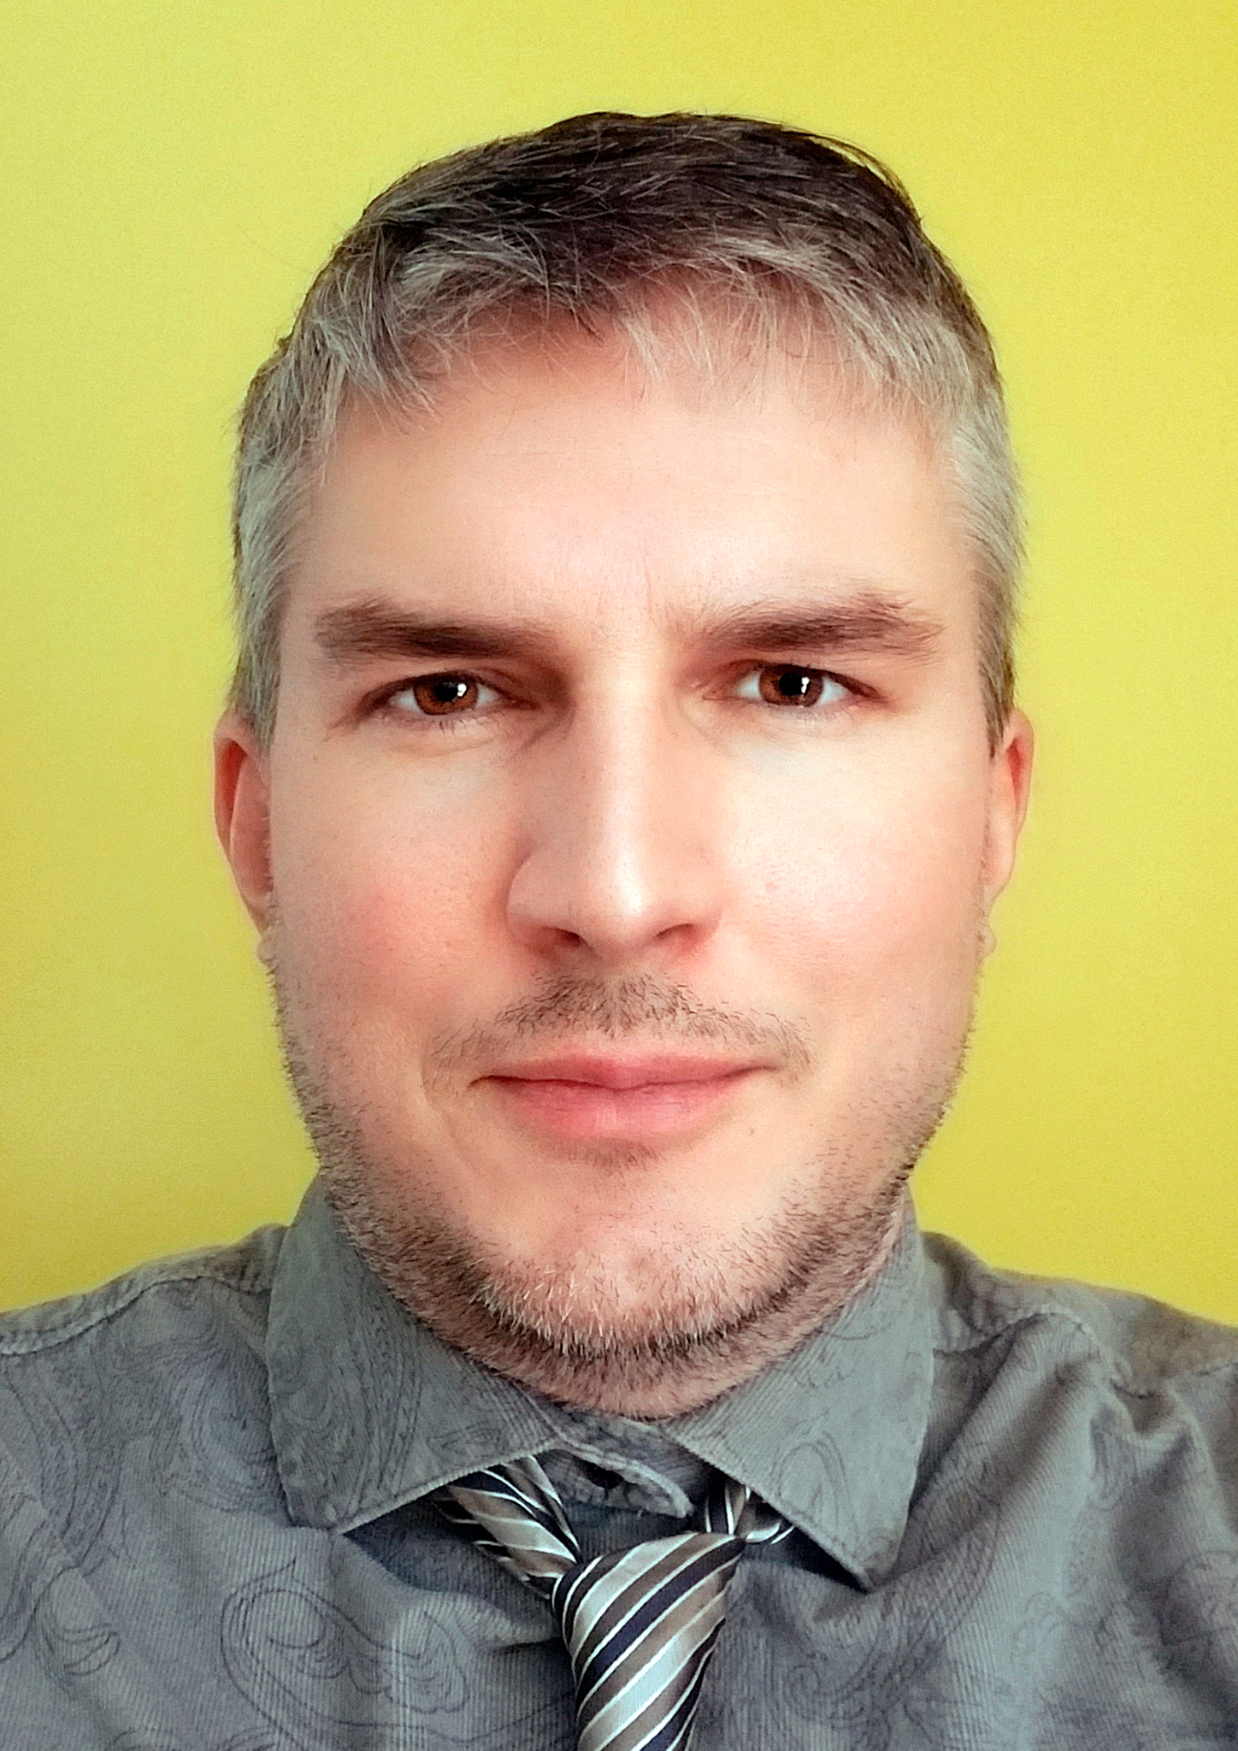
This service will be available starting immediately, at negotiable & fair rates. For more information about A1Retouching, visit https://www.a1retouching.com

